**RESTORING DIVISION ALGORITHM**

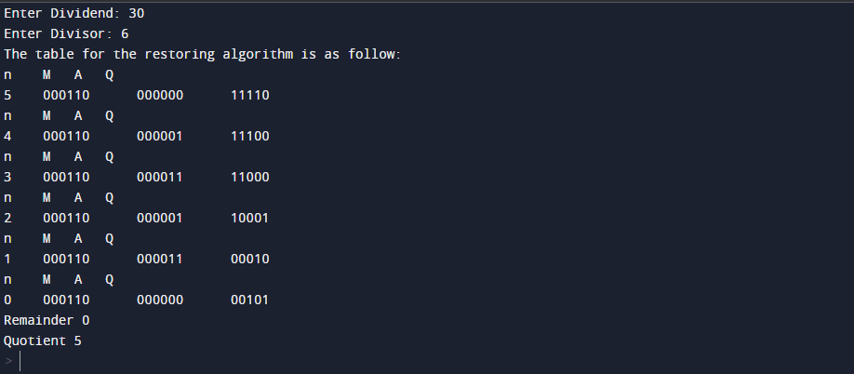

**NON-RESTORING DIVISION ALGORITHM**

